**Perceptive Content 7.1 Installation Guide**

Contents

Upgrading from Perceptive Content 7.1.0.378 to Perceptive Content 7.1.5.1539 2

New Installation of Perceptive Content 7.1.5.1539 Client 7

Connection Profiles 12

Server Addresses 16

# Upgrading from Perceptive Content 7.1.0.378 to Perceptive Content 7.1.5.1539

1. Download the installer from the OIT Site License Page <http://oit.duke.edu/comp-print/software/>
2. Right-click on the downloaded file and click “Run as Administrator”.
3. Depending on the version of Windows you are currently running, you may be prompted to install Microsoft .NET Framework 3.5 SP1. Accept this install. This can take several minutes to complete and may require a restart before you can move to the next step. Do not interrupt this installation.



1. The installer should recognize that this is an upgrade to the client. Once you receive this box, click “Yes”.



1. If you receive a box indicating that it is from an unknown publisher and asks if you are sure you want to proceed, click “Yes”.
2. Click “Next” in the Installation Wizard for Perceptive Content Desktop Client.



1. Scroll to the bottom of the license agreement, click the radio button “I accept the terms in the license agreement” and click “Next”.



1. Click on ImageNow Printer and Business Insight Integration and select to install them locally. Once this has been done, click “Next”.



1. When prompted for a Deployment Server URL, leave this blank and click “Next”.



1. Configure shortcut options as desired and click “Next”.



1. You are now ready to upgrade the application. Click “Install”.



1. Click “Finish” to complete the upgrade.



1. If prompted, click “Yes” to Reboot when possible.

# New Installation of Perceptive Content 7.1.5.1539 Client

1. Download the installer from the OIT Site License Page <http://oit.duke.edu/comp-print/software/>
2. Right-click on the downloaded file and click “Run as Administrator”.
3. Depending on the version of Windows you are currently running, you may be prompted to install Microsoft .NET Framework 3.5 SP1. Accept this install. This can take several minutes to complete and may require a restart before you can move to the next step. Do not interrupt this installation.



1. Click “Next” in the Installation Wizard for Perceptive Content Desktop Client. 
2. Scroll to the bottom of the license agreement, click the radio button that says “I accept the terms in the license agreement” and click “Next”.



1. Click on ImageNow Printer and Business Insight Integration and select to install them locally. Once this has been done, click “Next”.



1. Configure the Default Connection Profile as follows and click “Next”.

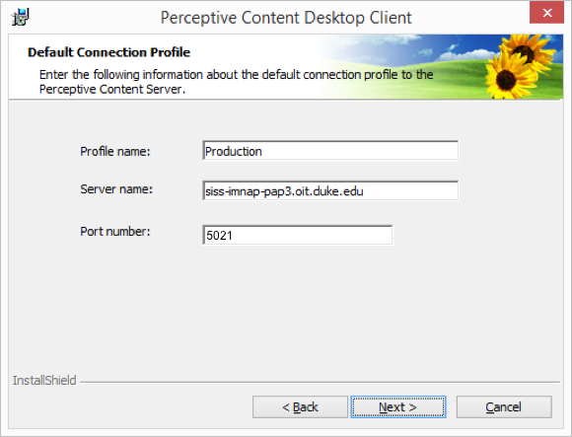

1. When prompted for a Deployment Server URL, leave this blank and click “Next”.



1. Configure shortcut options as desired and click “Next”.



1. You are now ready to install the application. Click “Install”.



1. Click “Finish” to complete the installation.



1. If prompted, click “Yes” to Reboot when possible.

# Connection Profiles

1. Launch Perceptive Content and click on the “Connection Profiles” tab.



1. Click “Edit connection profiles” at the bottom of the profile window. *You should already have a Production profile that was generated during the installation or carried over from the upgrade to 7.1.*



1. To edit and existing profile, select the one you need to adjust and click on “Modify”.



1. Make the adjustments and click “OK”.

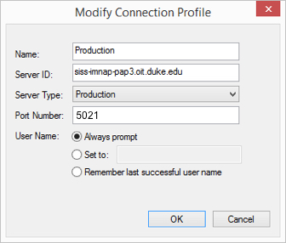

1. To create a new profile, click on “Create”.



1. Enter the Name as you want it to appear in the profile pane and the login window. Enter the server address, the type of environment the server resides in and the port. Choose the User Name option that best fits your needs. Click “OK” when you are finished.



1. You should now see the new profile. In this example, it is for the Test environment.



1. Adjust your default preferences, choose the profile you wish to use and click “OK” for it appear as the connection in the login window. Domain Authentication is not needed in the Duke environment.

# Server Addresses

**Production**

Production was upgraded to 7.1.5.1539 December 9, 2016. The 7.1.0.378 client can no longer be used to access Production.

Server ID: siss-imnap-pap3.oit.duke.edu

Port: 5021

**Test**

Test should only be added by power users who have been granted access to test the latest releases. Test is currently running 7.1.5.1539.

Server ID: siss-imnap-tap3.oit.duke.edu

Port: 5021